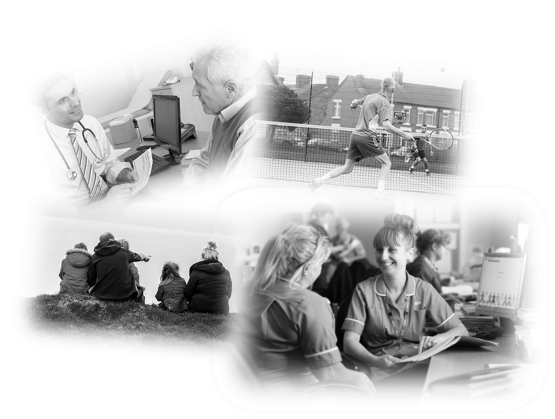

Healthy Wirral Place Programme

Annual Report for 2018-19

Contents

Page Number

Introduction 1

Mission statement and vision 3

Executive summary 4

Healthy Wirral Partners 6

Healthy Wirral
Achievements In 2018/19 7
Healthy Wirral Programme Development 7
Developing Our Place Programme 9

Integration Of Health And Care Systems And Partners 11
Integrating Health and Care Commissioning 11
Integrating Health and Care Provision 11

Primary Programme Development 12
Planned Care 12
Unplanned Care 12
Mental Health 13
Learning Disabilities 14
Women, Children and Families 14
Medicines Optimisation 15

People, Organisational Development & Leadership 17

Population Health Management 19
Population Health Intelligence 19
Population Health Priorities 20

Transformation 21

Financial Overview For 2018/19 And Year End Position 23

Financial Plan For 2019/20 And 5-Year Systen Sustainabiltity Strategy 25 Overview

Health Wirral System Operating Plan For 2019/20 28

Our 5 Year Strategic Plan 29

Introduction

We are very pleased to introduce the Healthy Wirral Annual Report for the year 2018/19
This is the first report of this kind and represents a significant development in our partnership to deliver better health and care through a place based approach on Wirral. We can only achieve this through the support and efforts of all our partners across the health and care system, and we hope that the progress during the past year highlighted in this report demonstrates our overall commitment to work together to achieve sustainable improvements in the health and wellbeing of the people of Wirral. 2018/19 has been a year of consolidation of our partnerships and building our future plans. 2019/20 and beyond will see the delivery of these plans through our operational plan, which will provide the basis for our long term strategy. Wirral continues to face significant challenges but also has great opportunities and we are confident that the progress we have seen in the last year will continue and allow us to work with our communities and staff to build a Healthy Wirral.

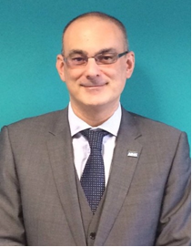
Simon Banks David Eva
Healthy Wirral Healthy Wirral
Senior Responsible Officer Independent Chair

‘Our vision is to enable all people in Wirral to live longer and healthier lives by taking simple steps of their own to improve their health and wellbeing. By achieving this together we can provide the very best health and social care services when people really need them, as close to home as possible’.

Healthy Wirral: Wirral’s Integrated Health and Care System
Wirral system partners recognise that it will only be through collective, actions as an integrated care system that we will deliver the best population health and wellbeing outcomes.

Our mission is:

‘Better health and wellbeing in Wirral by working together’

In order to deliver this mission, the Healthy Wirral partners have agreed a broad vision which is:

‘To enable all people in Wirral to live longer and healthier lives by taking simple steps of their own to improve their health and wellbeing. By achieving this together we can provide the very best health and social care services when people really need them, as close to home as possible’.

This vision stresses the importance of preventing ill health and people being cared for in the right place at the right time. Recognising also the need to live within our means as a system, we also aim to maximise the value of the ‘Wirral Pound’, by ensuring that this is invested in place based care that will deliver evidenced based, quality outcomes for the people of the Wirral. This requires our system partners to work collaboratively to deliver sustainable transformation across the system and support the following fundamental principles:
- Acting As One – exemplified in actions and behaviours. Delivering net system benefit
- Improving population health – delivering the Healthy Wirral outcomes around better care and better health using a place based approach
- Clinical Sustainability – sustainable, high quality, appropriately staffed, delivered across organisational boundaries
- Financial Sustainability – managing with our allocation, taking cost out, avoiding costs, delivering efficiency and better value
Executive Summary

In common with all health and care systems across Cheshire and Merseyside, Wirral is expected to establish and implement its plans to achieve the best possible health and wellbeing outcomes for its population within the funding available. The ‘Healthy Wirral’ programme is seen as the prime programme to deliver sustainable and affordable long term changes to the way that the health and wellbeing of the Wirral Population is supported.
2018/19 has been a year of development for the Healthy Wirral programme, commencing with a significant re-establishment of the programme; the development of a partners board with an independent chair, the creation of the programme team and the establishment of a comprehensive programme of primary and enabling work streams.
The establishment of a governance structure for the programme has involved the engagement and active participation of all partners. This partnership has been formalised through the development of a memorandum of understanding; approved by respective partner boards and governing bodies and enshrining partner commitment to ‘acting as one’. Adopting the principles of the controlled expenditure programme (CEP-Lite) ensure that transformation plans are sustainable and make the best use of the ‘Wirral Pound’.
The commitment to a place based approach to health and care delivery has centred on the establishment of a multi-agency and multi-disciplinary approach to supporting and caring for communities based on natural populations of 30,000- 50,000 people, and working closely with both statutory and voluntary services. The development of nine neighbourhoods has involved the engagement of all health and care sectors, and developing leadership at community level to act on population intelligence to find local solutions to local health and wellbeing challenges. This has been supported by the establishment of neighbourhood leadership teams, co-ordinated by G.P Neighbourhood Co-ordinators and involving key professionals and community leaders. In 2018/19 the primary challenge identified was the support of people whose level of frailty placed them at considerable risk and led to frequent unscheduled hospital admissions. Each neighbourhood will have its own story to tell about how they have approached their population challenges.

The case study below is just one example of how working together and taking a holistic approach to identifying solutions can yield real improvements for individuals as well as releasing time to care for professionals
Mrs A was frail lady of 85 who had been suffering from recurrent Urinary Tract Infections and problems with her medication, which had meant she had requested lots of GP home visit appointments in the last year. The frailty lead at her G.P Practice referred her to a Personal Independence Co-ordinator (PIC) who arranged to meet Mrs A and conduct a full holistic assessment through guided conversation.
Mrs A said that although she had a good supportive family, during the day she was feeling a little lonely and isolated. She had recently moved from Liverpool into sheltered accommodation on the Wirral, and although she often joined in with the coffee mornings she did not feel very connected to the community. She felt she was supported very well as she had a package of care, a falls detector and family visiting who support her with shopping.
The PIC worker arranged to keep regular contact with Mrs A and also connected her to Age UK Wirral Telephone Befriending service. To help improve her health the PIC purchased a “Hydrate motivational straw water bottle” for Mrs A and discussed the importance of drinking at regular intervals to reduce reoccurring Urinary Tract Infections. They also discussed whether further falls prevention support would be helpful.
During the first 3 months that Mrs A received support from PIC she had 5 G.P appointments, whereas in the previous year she had contacted the G.P 68 times. Mrs A reports that she feels much better following the PIC worker support and has found the regular befriending contact very helpful. She is regularly drinking more water using the measured bottle and has suffered much less urinary tract infections as a result

The achievements by Wirral partners outlined in this report are indicative of a significant shift within Wirral and a commitment to establishing an integrated care partnership that is focused on population health improvement as its primary objective. The development and agreement of a system operational plan has been a clear symbol of partner intentions to collaborate and remove organisational barriers to progress. The development of an ambitious and sustainable 5-year strategy for Healthy Wirral will provide proof of a system shift from planning to delivery against our identified priorities.

Healthy Wirral Partners
Delivering successful change across Wirral is entirely dependent on all of our partners working together. The Healthy Wirral programme continues to build partnerships with people and organisations that are focused on improving health and wellbeing for Wirral People. It would be impossible to list all our partners, but key organisations who have committed to this programme include:
Wirral Health and Care Commissioning
Wirral Council
Wirral University Teaching Hospitals NHS Foundation Trust
Cheshire and Wirral Partnership NHS Foundation Trust
Wirral Community Health and Care NHS Foundation Trust
Clatterbridge Cancer Centre NHS Foundation Trust
Primary Care Wirral GP Federation
GP-Wirral Federation
Community Action Wirral
Healthwatch Wirral

Healthy Wirral System Achievements in 2018/19
Healthy Wirral Programme Development
Leaders across Wirral have recognised that improving population health and delivering effective and affordable Health and Care services on Wirral will only be possible through a coordinated and integrated approach to the commissioning and delivery of services through a place based approach and focused on the needs of people within the communities they live in. In early 2018 a series of events were held, aimed at reviewing the progress of work to date and to commit organisations and resources to the re-establishment of a comprehensive place-based programme to deliver the vision of Healthy Wirral.
By April 2018 a programme team had been fully established, comprising an Independent Chair to lead the Healthy Wirral Partners Board, a Senior Responsible Officer, Programme Manager and Finance Lead. The work of senior leaders including this team has guided the programme development and some key changes designed to accelerate transformation outcomes, characterised by a number of achievements through the year.
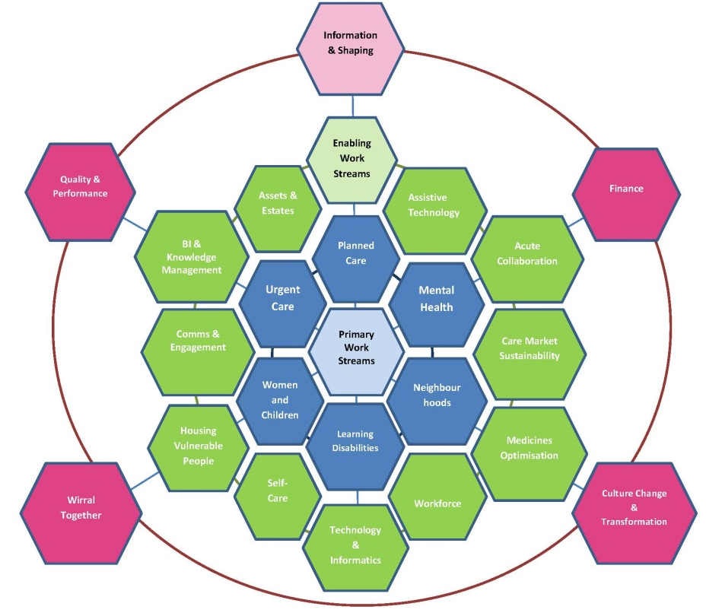
A detailed programme structure was developed to reflect the breadth of change programmes and the need for significant enabling support to achieve sustainable, large scale change and integration of transformation effort to deliver a place based system. Initially the programme consisted of 6 primary programmes and 11 enabling programmes, summarised in figure 1 below.

The Healthy Wirral programme team worked closely with colleagues and the Healthy Wirral Partners Board to identify executive sponsors and leads for all of these programme work streams. Each work stream was asked to develop a programme summary and plan on a page to clearly identify their programme plans, expected outcomes and benefits, and how their work stream integrated with other programmes, and in particular the development of neighbourhood based approaches.
System partners were asked to support these work streams and the overall governance of the programme. As part of a process of continuous review including the input from programme management experts, an amended programme infrastructure and governance was proposed which has reduced complexity and increased programme accountability and visibility to the Healthy Wirral Partners Board who have assumed a portfolio programme board role. The revised programme structure and governance are summarised in figure 2 below:
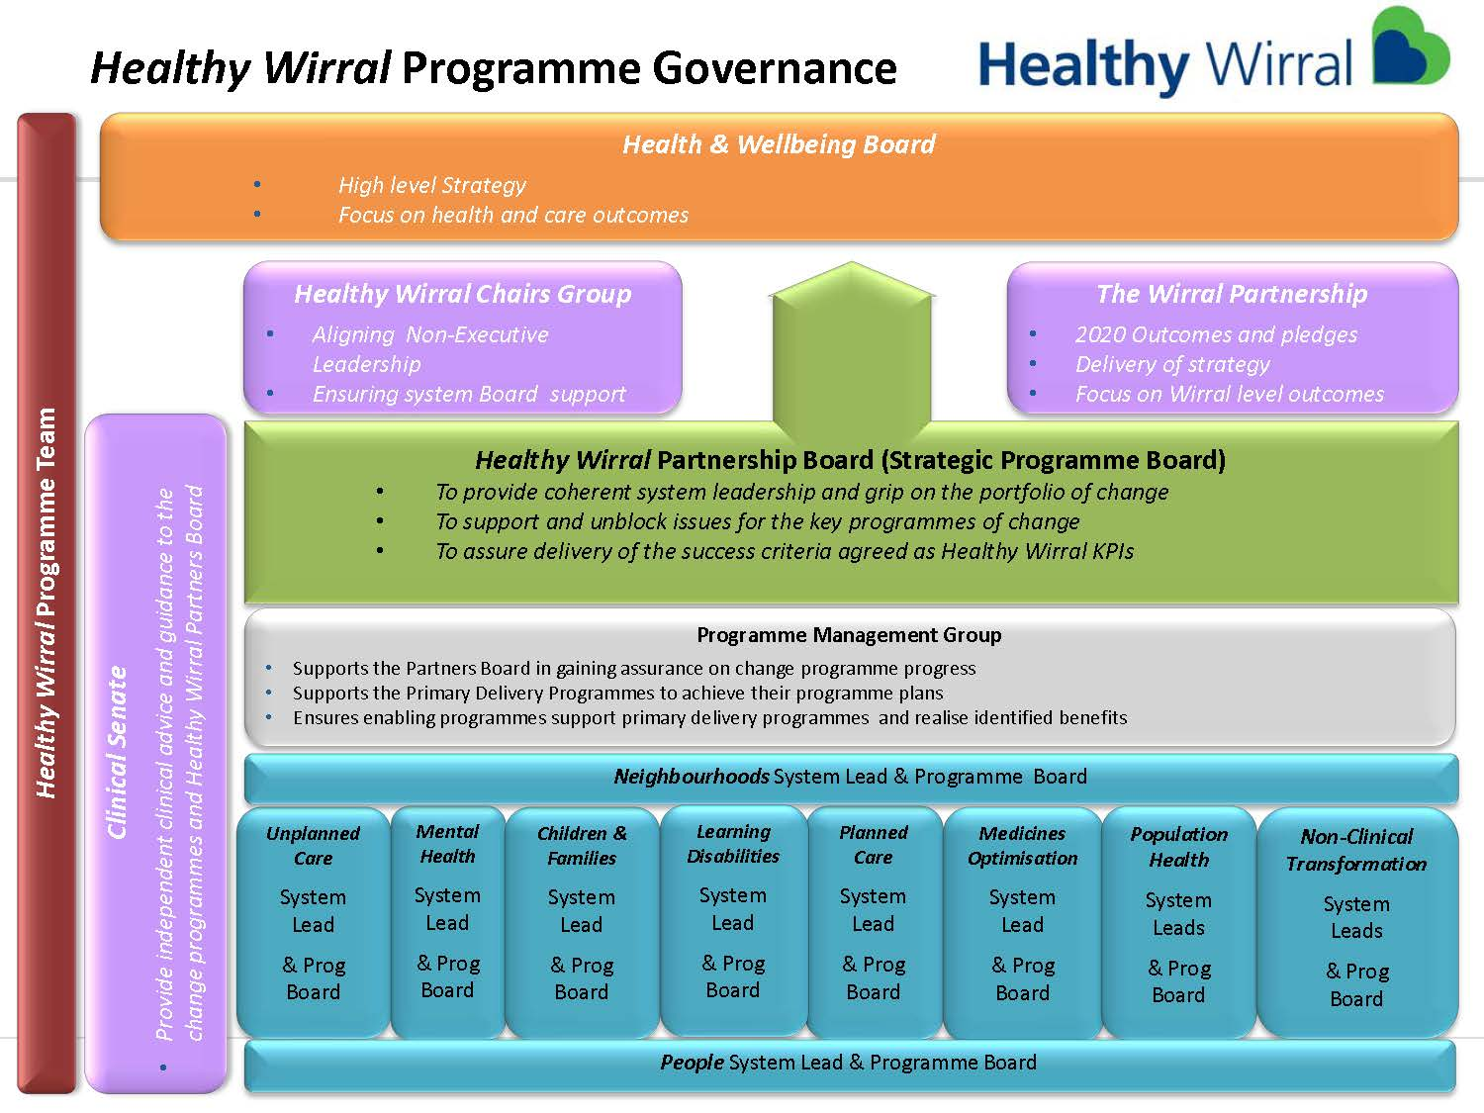

Developing our Place Programme
A focus on providing services at the most appropriate local ‘place’ level has led to the establishment of our Place Based Care System based on supporting health and delivering care at the most appropriate level. Our vision is for services to be delivered through 51 General Practices, nine neighbourhoods and one district. Each of the nine neighbourhoods is made up of a population of between 30 - 50,000 residents using health and care needs of the population as the foundation for the geographic boundary.
Primary care leaders, including General Practice (GPs), will be at the centre of the Place Based Care System, transforming community-based services and care pathways for a defined population.
Neighbourhood networks consist of an integrated workforce, with a strong focus on partnerships spanning primary, secondary, mental health and social care and importantly community and voluntary groups. They will also utilise the support (assets) available in their area to the benefit of their particular population. The aim is to improve outcomes for people and to deliver consistent and continuity of care.
The neighbourhood leadership teams have been established during 2018-19; led by a GP to ensure co-ordination of the neighbourhood team in the delivery of health and care pathways. There is a clear focus on the delivery of prevention, early intervention and proactive care to reduce the demand for reactive and specialist care.
Our vision for Neighbourhoods is:
Together we will provide effective care, as close to the resident’s home as possible, delivered by the right person at the right time
Our plans to deliver this involve:
- Organisation of care around people’s holistic needs - physical health, mental health and social care.
- Development of services that are clinically and financially sustainable through greater integration of care, reduction in duplication across a pathway and flexibility in approach of delivery to meet local population needs.
- Collaboration and involvement with a wider range of organisations from different sectors, including the identification and use of ‘community assets’
- Partnership working with families, carers and public and local neighbourhoods to transform the way that services are delivered and improve the focus on population health and wellbeing.
- Sharing of expertise and skills from different organisations to benefit how health and care is delivered.
- Making community-based care the central focus of the health and care system
- Releasing GP time to enable more effective, efficient and sustainable practices
We have made significant progress in defining and establishing neighbourhoods. GP Co-ordinators have been appointed to each of the nine neighbourhoods, leadership teams have been established and meet regularly. The neighbourhood teams have focused their early activity on the identification and management of frailty within their population, producing both neighbourhood level and practice level frailty plans submitted and commencing delivery of their action plans. Significant work has been undertaken in the alignment of resources and improving the links of community resources within neighbourhoods. Third sector links and provision have also been established and strengthened. This work has been supported by the development of robust and detailed population health intelligence aggregated at a neighbourhood level with the introduction of Neighbourhood intelligence profiles.
This work has been undertaken and overseen by the Senior Change Team, which comprises key clinical and organisational leaders from across the Wirral partnership. The work of this team and the neighbourhood leadership teams provides a firm basis for Wirral to continue to meet the ambitions of Healthy Wirral; working closely with Primary Care Networks and other key partners to ensure collective effort is aligned to develop an effective and responsive Place Based Care System focused on improving the health and wellbeing outcomes for our population

Integration of Health and Care systems and partners

Integrating Health and Care Commissioning
NHS Wirral CCG and sections of Wirral Council came together from May 2018 to form a single commissioning function, Wirral Health and Care Commissioning (WHCC). WHCC will jointly commission all age health, care and public health services for the Wirral population. WHCC will be responsible for setting the commissioning agenda and will lead the development of a Place Based Care System (PBCS) in Wirral. The focus will be on people and place, not on organisations. The transformation of service delivery is expected to reduce need for high cost acute care and improve health and wellbeing, reducing the need for long term care. The aim is to improve the outcomes for the people of Wirral and also to deliver sustainable services, both clinically and financially. Placed based care is being developed in response to the challenges Wirral health and care system faces of constrained funding, increasing demand, fragmentation of services and the need to deliver better health, better care and better value for the people of Wirral.

Integrating Health and Care Provision
Following negotiations between key health and care partners in Wirral, adult social care services were transferred into Wirral Community NHS Foundation Trust in June 2017. Following this, in August 2018 the all Age Disability Social Care teams were transferred into Cheshire and Wirral Partnership NHS Foundation Trust. This has served to integrate the frontline assessment and support planning processes for vulnerable adults and older people across the health and care delivery pathway, and which will provide joined up seamless health and social care delivery services for Wirral people.
Following a period of stabilisation and integration of these teams into their new organisations, and organisational development processes to establish strong operational and contract management processes, it is planned that 2019/20 will be a year of transformation, establishing true integration of health and care teams, enabling integrated partnership working for local people through strong multi-disciplinary teams operating at a neighbourhood level.

Primary Programme Development
Planned Care
Significant work has been undertaken in year to support the development of effective planned care, focusing on improvement of referral to Treatment times and the transformation of Musculoskeletal (MSK) services.
Wirral implemented a new MSK Integrated Triage Service in 2018; this applies the key principles of the MSK First Contact model and is achieving reductions to diagnostics and reductions in secondary care referrals in line with the model.
A key development within the 2018/19 planned care programme was the redesign of heart failure services, and the development of a community heart failure service. This has been successfully launched and includes community based intravenous diuretic therapy.
In order to ensure that the planned care programme is focused on the areas that can will have the greatest impact for the system, the programme team and the Planned Care Board have undertaken a mapping process to identify the key priorities. The team have worked with the Right Care and Model Hospital teams as part of this process and have identified the following priority areas which they have commenced their clinical redesign and transformation programmes:
- Cardio-vascular disease, building on the successful work undertaken in Heart Failure re-design in 2018-19, including prevention, rehabilitation and early supported discharge for stroke.
- Respiratory/ Chronic Obstructive Pulmonary Disease (COPD) services to include prevention diagnosis, management, admission avoidance and monitoring
- Gastrointestinal services, including diagnostic, community and secondary care pathways
- Out Patients redesign, working with hospital colleagues, primary care and community services to identify alternative approaches and community based support.
Unplanned Care
Notable progress has been made in relation to the delivery of improvements to our urgent and unplanned care in Wirral. This has included:
- Delivering and maintaining Delayed Transfer of Care (DToC) performance
- Establishing streaming from Emergency Department (ED) to Primary Care with a new model in place since November 2018
- The Wirral Single Point of Access is now fully co-located, bringing together 3 areas (mental health, physical health and social care duty).
- The High Impact change model work undertaken has supported the delivery of a Trusted Assessor model for our Transfer to Assess service
- Delivery of an effective teletriage and improved support to care homes, which is showing reductions in ED attendances and calls to 111 and 999.

A detailed review of urgent care services was undertaken, building on work that had commenced in 2016. During 2018-19 extensive consultation on the options for delivering responsive and effective care was undertaken; engaging with Wirral people, clinicians and other key stakeholders to ensure the final model would both meet local needs and deliver nationally mandated changes including an Urgent Treatment Centre for Wirral. The Clinical Senate for Greater Manchester, Lancashire and South Cumbria also visited Wirral during the consultation period to provide an independent clinical view of the proposals Work priorities in 2019-20 will be to finalise and begin implementation of the recommended changes, focusing on Admission Avoidance, Acute Flow and Discharge/ Step Down.

Mental Health
Our vision is to establish an integrated service with seamless patient pathways, aligning primary and secondary mental health services and integrated with community level interventions including social prescribing.
Good progress to achieve our vision has been made to date. Action has been focused on the Talking Together, Live Well Wirral programme which has been developed within the wider Improving Access to Psychological Therapies (IAPT) service specification written during 2018. A procurement exercise undertaken, resulting in award to Insight Healthcare who deliver the IAPT service in line with a number of strategic partners, both statutory and third sector from April 2019.

Learning Disabilities
National specifications for both the Community Learning Disability Teams and Assessment and Treatment Units have been localised and are being implemented across Cheshire & Wirral, with Wirral leading this work. Non recurrent pump priming monies have been obtained from NHS England to support the delivery of the Intensive Support Service function of the Community Learning Disability Teams across Cheshire & Wirral. Recurrent money for this function has now also been identified from the planned redesign of short breaks services and this will support the long-term delivery of the Transforming Care Programme.
Work has commenced to increase the number of health checks completed, including health action plans. A scoping exercise has commenced to establish the reasons for low completion rates which involves the GP lead for LD, business intelligence teams and health facilitators from Cheshire and Wirral Partnership NHS Foundation Trust. A draft information pack has been developed for primary care and inclusion at GP members/neighbourhood sessions.
A project group for stopping over medication of people with a learning disability and /or autism (STOMP) and Supporting Treatment and Appropriate Medication in Paediatrics (STAMP) has been established and pilot projects have been completed. Information has been disseminated to primary care and initial work regarding awareness/e learning for GPs has been completed and will be progressed in 19-20.
As part of the All Age Disability Strategy Action Plan Wirral has achieved an increase to 50% in the number of people with a long-term condition or disability who are employed. This is an increase from 37% at the start of the Wirral Plan in 2015/16.

Women, Children and Families
The Healthy Child Programme (0-19 years) provides a framework to support collaborative work and more integrated delivery of services for children and young people. The 0-5 element of the Healthy Child Programme is led by health visiting services and the 5-19 element is led by school nursing services, providing place-based services and working in partnership with education and other providers.
Additional support around Health Improvement including areas such as emotional health and wellbeing, sexual health and substance misuse further compliments this offer. The universal reach of the Healthy Child Programme provides an invaluable opportunity from early in a child’s life to identify families that are in need of additional support and children who are at risk of poor outcomes. The 0-19 Service has been in operation in Wirral for just over 4 years and has seen progress in a number of areas, including uptake of developmental reviews for children, the implementation of integrated reviews and the establishment of health and wellbeing hubs in 4 localities to increase access to services.

Medicines Optimisation
The Medicines Value Programme for Wirral has been established to improve health outcomes from medicines through improving patient information, making best use of the clinical skills of pharmacists and pharmacy technicians, and implementing clinically effective prescribing and medicines reviews to ensure we are getting the best value from our medicine’s expenditure. The programme has made good progress in 2018-19, building a firm foundation for transformation work in 2019-20. A multi sector partner group established which has been formally established as the programme board for the Medicines Optimisation transformation programme. A workforce map for all sectors has been completed and communicated and a successful system educational event has been held.
GP practice based Clinical Pharmacists (GPCPs) commenced working across both primary and secondary care in April 2018. The programme is now live in 13 practices. A development linked to this programme has been the introduction of the deteriorating patient which allows community pharmacists to directly contact GPCPs where they have concerns.
Biosimilar medicines are biological medicines which is highly similar to another biological medicine already licensed for use and have been shown not to have any clinically meaningful differences from the original biological medicine in terms of quality, safety and efficacy. A Biosimilar oversight group has established which has delivered significant system savings based on the delivery of a range of biosimilar drugs.

The Medicines Optimisation in Care Home (MOCH) programme commenced in 2018-19 and staff recruited as part of an NHS England pilot in January to support existing care home pharmacists.
Mental Health medicines developments have included targeted electronic referrals to Community Pharmacy; concentrating on antidepressant medicines use review (MUR) to support suicide prevention, antipsychotic MUR to support relapse prevention, and improved adherence with medicines for diabetes or hypertension and inhalers to support admissions prevention. Targeted electronic referrals have also commenced to notify of Clozapine treatment alerting community pharmacists to likely complications such as bowel obstruction, dyscrasias, and the impact of smoking and other drug interactions on clozapine levels in order to reduce admissions. An in-reach service to the Wirral University Teaching Hospitals Trust has been agreed to support medicines optimisation for mental health medicines in response to the National Confidential Enquiry into Patient Outcome and Death report (NCEPOD) which reviews clinical practice and identifies potentially remediable factors in the practice of patient care..
A 4-month NHSE funded STOMP pilot across 3 GP practices has been undertaken during which all patients with learning difficulties and concurrent antipsychotic prescriptions were reviewed by specialist mental health pharmacist.
Work commenced on the development of Health-e-Intent population health intelligence platform to analyse medicines practice and drive performance improvements relating to antimicrobial and antibiotic prescription

People, Organisational Development & Leadership

Wirral partners have a shared ambition to develop an effective and sustainable workforce, whose capability (capacity, competence and confidence) is aligned to the vision and aims of Healthy Wirral. This has resulted in a commitment to delivering a place-based approach to the development of a Wirral People strategy and delivery plan. Wirral is adopting a system approach to mapping system capability and modelling future workforce needs. Aligning this work to the wider place-based programmes of work and working in partnership with system colleagues in Cheshire West, Wirral will implement an Aligning Capability model to analyse current issues and future needs.
A primary focus of this work will be integration with the core and primary transformation programmes to ensure that future workforce needs are addressed. As the key agent of the delivery of place-based health and care, neighbourhood/ primary care network development will be the initial priority for the People programme.
Working closely with wider system partners across Wirral during 2018/19 has led to the development of a number of initial strategic priorities. These have been incorporated into the key system deliverables for 2019/20 and will used to inform the Wirral long term People strategy. A successful bid was made to the Cheshire and Merseyside Local Workforce Advisory Board to support the delivery of these priorities, and in particular establish our innovative approach to understanding and analysing system and people capability in order to build a strong workforce, organisational and people strategy. Key elements of this include:

- Mapping and evaluation of system capability including workforce requirements and gaps
- Aligning Capability gap analysis of neighbourhoods to inform Wirral and local neighbourhood People and Organisational Development delivery plans
- Development of Wirral People Strategy and Delivery Plan
- Establishment and delivery of a research programme to evaluate the programme and methodology, to ensure shared learning across the Cheshire and Merseyside Health and Care Partnership footprint and beyond
- Building on the system capability profiles to develop a single system offer for new roles, aligned to our place and neighbourhood programme
- Explore the opportunities for joint education and training programmes to support system organisational and workforce development

Following successful engagement with the North West Leadership Academy Wirral is working in partnership with North West Employers to deliver a Neighbourhood and Network Leadership Development programme to support integrated system leadership and co-production, and develop leadership skillset for network leaders.

Population Health Intelligence
Healthy Wirral partners have established an integrated Population Health Intelligence Work Programme with the aim of improving the health and wellbeing of our communities through the effective use of population health intelligence.
The programme delivery group has brought together subject matter experts from across the Wirral health and care system and provides a strategic lead for Healthy Wirral Population Health Intelligence. The programme aims to support the use of intelligence, including the analytics opportunities offered by the developing Wirral Care Record to identify opportunities to improve care quality, efficiency and equity. The programme will also support and evaluate service transformation
The programme group is working to improve understanding of the analytical capacity and capability within the system and develop a plan to meet future analytical capability requirements, and have undertaken a comprehensive skills audit in support of this. Key system benefits that have been identified include:
- Enhancing the experience of care
- Improving the health and well-being of the population
Population Health Management
- Reducing per capita cost of health care and improve productivity
- Addressing health and care inequalities
- Increasing the well-being and engagement of the workforce
In support of this work system partners have implemented the Health Information Exchange (HIE) system which allows clinicians to view live clinical information across the key Wirral providers, establishing a real time profile of care to support effective clinical decision making
On-going work to develop the Wirral Population Health Management System (Wirral Care Record) has included integration, standardisation and merging of data for primary and secondary care, including validation and testing of data. A key area of progress has been the development and implementation of the five initial registries (Adult and Paediatric Diabetes, Adult and Paediatric Asthma and COPD) together with two additional registries for frailty and end of life.

Population Health Priorities
Public Health information and the analytical work undertaken by system colleagues, including the Wirral Intelligence Service have provided a clear set of priorities to focus on in terms of population health planning and management. Our focus this year has been and will continue to be on the following priorities in 2019/20:

- Alcohol Misuse through encouraging a responsible relationship with alcohol through opportunistic early identification and brief advice (IBA), and supporting those who need help with alcohol misuse through strong engagement, treatment and recovery
- Smoking through early intervention with children and young people, ensuring robust and easy to navigate smoking cessation pathways that are seamless between care sectors and through targeted campaigns to promote smoking cessation
- Air Quality improvement through working with colleagues across the Liverpool City Region and North West to develop the approach locally
- Wirral Residents and Health Inequalities through ensuring our plans are aligned with the Wirral 2030 plan, physical regeneration strategies and the development of the ‘Wirral Together’ approach to working with local people
- Self-care through creating whole population health and wellbeing by mobilising community assets and building social networks, developing a proactive and universal offer of support to people with long term physical and mental health conditions to improve their ability to self-manage
- Health Protection Priorities for Wirral through the development of a system wide approach to Infection Prevention and Control, reducing antimicrobial and antibiotic resistance and reducing the variation and uptake of cancer screening and national immunisation programmes.

Transformation

Transformation has been significantly focused upon the development of Place on Wirral. This has been characterised by a number of primary developments to deliver Integrated Neighbourhood Hubs and enabling programmes to establish related infrastructure including our Urgent Care strategy and Single Point of Access development.
Following the work in 2017-18 with leaders and clinicians across Wirral and supported by the Advancing Quality Alliance (AQuA) to develop a Strategic Outline Case that formed the basis of developing our target operating model we developed Healthy Wirral Partners Board which is overseeing the key work streams involved in the delivery of the model and associated pathways.
The development of the Wirral Integrated Commissioning Strategy establishes a Place based commissioning and care transformation programme designed to deliver fundamental change in order to achieve Place based and Population health focused care and support on Wirral.
A fundamental element of the Wirral Place programme is the development of our neighbourhood infrastructure. This builds on the integration we have already achieved through the development of four integrated health and social care hubs (ICCHs), plus more recently on the organisational integration of adult social care assessment and provision into Wirral Community NHS Foundation Trust and the development of an integrated commissioning function for health and social care.
Our Senior Change Team brings together all system partners including clinical leaders, and they have been responsible for building an understanding of what neighbourhood and networks will require both clinically and organisationally, including the development of pilot programmes to inform the final operating model. The neighbourhood based model is seen as a key element of delivering our ambition for an effective and comprehensive pathway for our population, and transformation effort in 2018-19 has focused initially on our frail population and building strong place based links with primary care having already made significant progress with integrating community services.

Funding to support Transformation in 2018-19
System partners have committed resources of circa £186k to support the establishment and development of the Healthy Wirral transformation programme team, including the independent chair, programme manager and finance lead roles. This resource has supported the wider transformation effort across the programme, and has successfully attracted further transformation funding from a number of sources to support the Healthy Wirral programme.
Working closely with system partners, the programme team successfully gained £600k of transformation funding from the Cheshire and Wirral Health and Care Partnership to support the development of place. This funding has been focused on a number of key initiatives including:
- Establishing and supporting the development of neighbourhoods. This has included the recruitment of 9 G.P Neighbourhood Co-ordinators who have worked to bring together a multi-agency team together to support local development, including the delivery of neighbourhood plans designed to better support frail people within the neighbourhoods and reduce non-elective admissions to hospital. Practice teams including G.P and practice manager time support was provided to support primary care involvement in this programme. Programme management input was also established for the neighbourhood programme, and to support community partner development and redesign to align resources with neighbourhoods.
- Building our business intelligence capacity and capability through the development of systems to support real time dashboards to support management of frailty, undertake risk stratification and understand variance across the system
- Supporting Organisational Development to create and align system leadership and capacity to ‘act as one’ in the delivery of system transformation and establish truly integrated approaches to the commissioning and provision of care on Wirral.

£184K has been successfully awarded from Health Education England Local Workforce Advisory Board (LWAB) to support our ‘aligning capability’ People programme and a further £6k from the NHS North West Leadership Academy to support leadership development for neighbourhood and primary care network teams.

Financial Overview for 2018/19 and Year End Position

The Wirral Health and Care system continues to face significant challenges to achieve financial recovery and sustainability. The Healthy Wirral programme recognises and supports the aspiration to live within our means as a system and the aim to maximise the value of the Wirral pound, by ensuring that this is invested in place based care that will deliver evidenced based, quantifiable quality outcomes for the population of the Wirral.
Income & Expenditure Performance
I&E performance (Incl. STF)  Surplus / (Deficit) | Plan  £’000 | Actual  £’000 | Variance  £’000
CWP (Wirral proportion) | 246 | 742 | 496
Wirral Community | 2,193 | 3,723 | 1,530
WUTH | (25,042) | (33,008) | (7,966)
Wirral CCG | 2,000 | 2,003 | 3
Wirral LA | 0 | 0 | 0
Total | (20,603) | (26,540) | (5,937)
Note: the above excludes impairments and other below line adjustments

The table above shows a system deficit of £26.5m for 2018/19 (£5.9m off plan), however this was an improved position on the forecast outturn predominantly due to additional provider sustainability incentive funding for both Wirral Community Health and Care Trust and Cheshire and Wirral Partnership at £1.9m received at the year end.
There were a number of key pressures across the system in year, primarily due to outsourcing costs for elective activity due to non-elective demand at the beginning of the year, along with costs for additional beds at Clatterbridge hospital, CCG costs relating to out of hospital packages of care and a shortfall in delivering the required savings plan at both WUTH and WCCG. Non recurrent support and contingency offset pressures however for the CCG to bring them back into balance at the year end.
Cost Improvement Plan (CIP)/Quality, Innovation, Productivity and Prevention (QIPP) Savings Plan

CIP/QIPP Performance | Plan  £’000 | Actual  £’000 | Variance  £’000
CWP (Wirral proportion) | 980 | 980 | 0
Wirral Community | 2,500 | 2,502 | 2
WUTH | 11,000 | 9,568 | (1,432)
Wirral CCG | 19,639 | 11,582 | (7,957)
Wirral LA | 1,500 | 1,500 | 0
Total | 35,619 | 26,232 | (9,387)

The table above shows system savings delivered of £26.2m against a plan of £35.6m. Although the savings delivered were significantly below plan due to the challenging target required for the CCG the overall system savings achieved represents delivery of almost 4% which is a great achievement.

Underlying System Deficit
Although the system deficit for 2018/19 is £26.5m there are a number of non-recurrent benefits which mask the real underlying deficit to be carried forward for the system at c£45m and will be factored into the 2019/20 plan and the long term financial recovery plan.

Financial Plan for 2019/20 and 5-Year System Sustainability Strategy Overview
The approach taken by the Wirral system for 2019/20 is for partners to work together to help providers deliver their control totals in order to secure external central funding of c£20m. The system has also recognised that savings plans need to be recognised on a cost out basis and not on a tariff basis. System partners have acted collaboratively with agreed and aligned contract activity and financial baselines across the system, however in so doing the financial risk for the system now lies with WCCG.
The table below summarises the 2019/20 plan with a planned system deficit of £1.1m to reconcile to individual control totals and a risk adjusted deficit of £13.6m to reflect the CCG financial risk of £14.8m.

Wirral System Summary (exd LA) | WUTH | WCT | CWP (prp’n) | WCCG | System Total
 | £’000 | £’000 | £’000 | £’000 | £’000
19/20 deficit before CIP/QUIPP and central monies | (32,005) | (1,995) | (1,117) | (24,245) | (59,362)
CIP/QIPP | 13,201 | 2,000 | 965 | 24,245 | 40,411
MRET central funding | 6,282 |  |  |  | 6,282
PSF allocation | 6,872 | 990 | 304 |  | 8,166
FRF allocation | 5,650 |  |  |  | 5,650
19/20 Submitted Net Planned Surplus / (Deficit) | 0 | 995 | 151 | 0 | 1,146
Risk adjustment |  |  |  | (14,793) | (14,793)
Risk adjustment Planned Surplus / (Deficit) | 0 | 995 | 151 | (14,793) | (13,647)

Definitions:
MRET Marginal Rate Emergency Tariff
PSF Provider Sustainability Fund
FRF Financial Recovery Fund

A key outcome of the current HW programme will be the development of a whole system plan to achieve system financial sustainability, through service transformation and the delivery of challenging system wide efficiency and cost improvement programmes.
There are a number of organisational specific CIP/QIPP savings schemes, however there are a number of key system programmes which have been prioritised in 2019/20.
In supporting the delivery of these plans, Healthy Wirral system partners have also committed to delivering future system sustainability, adopting the principles of the Capped Expenditure Programme; CEP-Lite. System efficiencies will be sought through the agency of the Healthy Wirral core and primary programmes and the delivery of effective place-based neighbourhood health and care approaches.
Key system-wide efficiencies will be implemented in 2019/20 through an agreed whole system focus on the following priorities:
- Outpatient redesign – delivering the reform required in the Long-Term Plan and shifting services towards neighbourhoods/Primary Care Networks.
- Non-Elective Admissions reform and improving flow through reduced Length of Stay predominantly for High Intensity Users.
- Medicines Optimisation – working as a system to reduce waste, support effective prescribing and reduce cost.
- Developing Neighbourhoods/Primary Care Networks as service delivery networks and shifting services towards them.
- Further developing community out of hospital care approaches.

2019/20 plans are being aligned with long term transformation priorities to ensure that change can be achieved that is sustainable at a system level.

The approach to delivering sustainability will be to contain costs via the transformation priorities and subsequently utilise the growth element within the CCG allocations and therefore reduce the CCG and system deficit. This will be further developed in our 5 year sustainability strategy.

Clear mechanisms have been established to ensure that the system is effectively monitoring the impact of efficiencies on the quality of care. The following key governance strands have been put in place to enable this:
- All the programme boards for the key primary programmes have clinical oversight and leadership, for example the Planned Care Board is chaired by the CCG Medical Director
- Wirral is developing an independent Clinical Senate to provide oversight, clinical leadership and challenge to programmes. The senate has representation from across the clinical and professional community of Wirral health and care commissioning and provision.
- All programmes are subject to Quality and Equality impact assessment processes established and overseen by the Director of Quality and Safety for Wirral Health and Care Commissioning

Healthy Wirral System Operating Plan for 2019/20

Following the agreement of the 5-year settlement for the NHS and the development of the NHS Long Term Plan in 2019, guidance has been provided to clarify the expectations of all integrated care systems to produce organisational level and coherent system level operational plans for 2019-20. This year is identified as a foundation year to lay out the groundwork for implementation of the long term plan and the up-front funding for providers is given with the requirement that each NHS organisation delivers its agreed financial position. The production of operating plans for 2019/20 will support the development of a broader 5-year strategic system plan. In addition to delivering the requirements of the NHS Long Term Plan, Healthy Wirral partners have recognised this as an opportunity to set out our ambitions for place based population health and care and align this with Wirral system planning including the Wirral 2030 plan.
As an outcome of a Healthy Wirra event in November 2018 and subsequent discussions, all partners committed to a joint approach to the completion of a Wirral System Operating Plan for 2019/20. Following the publication of full guidance by NHS England in January 2019, system partners, led by the Healthy Wirral have worked to deliver the expected milestones, and submitted a draft system operating plan on 12th February 2019. The Healthy Wirral Partners Board took oversight of the delivery of the plan and approved the final version on 28th March 2019 and the final plan was submitted to NHS England and the Cheshire and Merseyside Health and Care Partnership on 4th April 2019. Key to this plan is the alignment with system partner operational plans particularly in respect of strategic intent and priorities, financial and activity assumptions.

Our 5 Year Strategic Plan

Our 2019/20 Operating Plan provides a strong basis for system wide discussions and activity to establish and agree a Healthy Wirral 5-year Strategic Plan. Our ambition is to develop a draft plan by July 2019 in preparation for submission in the autumn of 2019.
In support of this work the Healthy Wirral programme team have developed a ‘Plan on a Page’ (Summarised in Figure 3) setting out our broad strategic ambitions and our approach to delivering transformational change. These plans will provide a framework for Healthy Wirral partners, supported by the programme team, to build on the work undertaken in 2018/19 to draft this strategy and establish a comprehensive engagement process with the Wirral community to co-design the plan.

Figure 3: Healthy Wirral Plan on a Page
PLACE Title | Healthy Wirral
PLACE purpose/vision | To enable all people in Wirral to live longer and healthier lives by taking simple steps of their own to improve their health and wellbeing. By achieving this together we can provide the very best health and social care services when people really need them, as close to home as possible
Why are we doing this? | Wirral has significant population health challenges. We have an ageing population and significant variation in health and wellbeing outcomes across our geography. Demand on the system is increasing and without significant transformation there will be insufficient funding to maintain the quality and standards that we want our population to experience.
How are we going to do it? | We will take a place-based system approach to transforming our services to ensure they meet the changing needs of our population and allow us to deliver safe and effective care within the resources available to us. We will do this by:  - Acting as One: Exemplified in actions and behaviours. Delivering net system benefit  - Clinical Sustainability: Sustainable, high quality, appropriately staffed, organisationally agnostic services.  - Improving Population Health: Delivering the Healthy Wirral outcomes around better care and better health using a place based approach.  - Financial Sustainability: Managing with our allocation, taking cost out, avoiding costs, delivering efficiency and better value  - Effective Engagement - working with our public and patients to promote self-care by involving them in all decisions made about them.
How we will work together? | - We will actively engage and work collaboratively and in good faith at all times in connection with the Healthy Wirral programme and be open, honest and transparent in all dealings.  - We will jointly own the financial challenge and any agreed actions to address this and put mechanisms in place to ensure patient safety is not put at risk.  - We will ensure the effective stewardship of financial resources and will share skills, knowledge, experience and resources effectively and in a prioritised way to sustainably deliver the best possible health and care outcomes for the people of Wirral.  - We will engage effectively with clinicians and operational leads across the system, to deliver transformational change through the development of place-based, clinically effective and organisationally agnostic health and care pathways. We will work collectively and in partnership with Wirral people to deliver improved population health.
What will be the outcome(s)? | Big 5 – larger deliverables (require more investment/potentially more sensitive/controversial) | Fast 5 – JDI’s/quick wins
 | Wirral Organisational Development strategy implemented to deliver integrated place–based care | Effective Neighbourhood based operating model
 | Integrated Urgent Care Transformation | Reduction in Non-elective admissions and ED attendances for frail and high intensity service users
 | Sustainable financial strategy | Improved care and value outcomes through the implementation of Medicines Optimisation approaches
 | Implementation of Population Health Programme and full adoption of the Wirral Care Record | Improved care outcomes and efficiency through shared service approaches within neighbourhoods
 | Improved patient experience and increased care closer to home through Out-patient redesign | Identification of key specialties and pathways for redesign in 2019/20 based on Right Care and GIRFT data.
What will the benefits be? | - Children are supported to have a healthy start in life  - People are supported to have a good quality of life  - Inequalities in healthy life expectancy are reduced  - People are supported to be as independent as possible, and when they need care can access timely responsive and high quality care and support, and have informed choice and control over services  - People feel safe and respected and are kept safe and free from avoidable harm  - People and their families can access jargon free information and are engaged in the setting of their outcomes and the management of their care, from organisations that talk to each other  - People are supported by skilled staff, delivering seamless, person centred care  - People access acute care only when they need to  - Financial Balance is achieved  - People can access shared and integrated information  - Interventions happen earlier to prevent health problems
Main Milestones | Milestone: |  | By When:
 | Healthy Wirral System Operational Plan |  | April 2019
 | Healthy Wirral 5 Year System Sustainability Strategy |  | Autumn 2019
Interdependencies | Which other programmes or outputs is the Place programme reliant upon? | What will the Place programme enable elsewhere in the health system?
 | Carter at Scale (Non-clinical) programme | Shared learning around Place based workforce strategy
 | Cardio-vascular programme | Health and Care Integration
 | Workforce Programme | Shared learning on Neighbourhood Leadership development

