Helpsheet ?
Ovid User Guide

Contents
A: Accessing Ovid Databases and Creating a Personal Account 1
B: Searching for Terms 3
C: Searching for Subject Headings 6
D: Combining Search Terms and Subject Headings 7
E: Filtering and Saving Results 9

A: Accessing Ovid Databases and Creating a Personal Account

1. Accessing OVID Databases
- Go to the Library Website For Library and Knowledge Services | Wirral University Hospital NHS Foundation Trust (wuth.nhs.uk)

- Using the gateway to the Knowledge Hub select ‘Search’
- Click on the yellow bar at the top of the page at sign in with your OpenAthens username and password
- Under the heading ‘In-depth searching’ select the database you wish to search e.g. EMBASE or MEDLINE

This will take you to the following Ovid front page.

2. Select the database you want to search, for instance Medline. Then click “OK”. We recommend searching one database at a time:

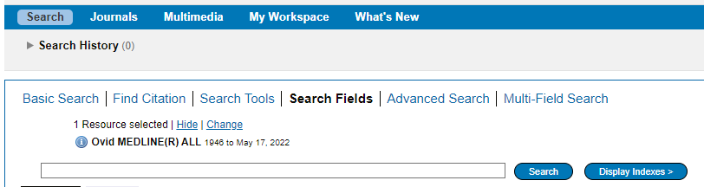

3. Once you have selected a database, you can begin searching. However, you will first need to create a personal/research account to save your searches and results. If you already have a personal account, login to it now.

Click on “My Workspace” or “My Account” – they will both take you to the login/registration screen.

4. From here, either sign into your existing Personal Account, or select “Create Account”:

B: Searching for Terms

To get back to the Ovid search page, click on the “Search” icon on the top left:

5. To start a search, click on “Search Fields”:

6. You can now start entering your search terms in the search box.

“All fields” is automatically selected. Alternatively, you can select specific fields to search e.g. Abstract, and Title.

Once you’ve entered your search term, select “Search”:

7. The results appear under the list of fields – you may find it easier to click on either “Advanced Search” or “Multi-field Search” as this will mean less scrolling down the screen.

8. Your strategy so far will show at the top of the screen.

Only the 4 most recent search lines are displayed automatically. To see the full search, click “Expand” on the right of the screen:

Repeat steps 5-8 for all keywords.

9. To save your search so far, click “Save All”.

Enter a search name, Select Type as “Permanent” . If you are updating an existing search, ensure that “Ignore Warning” is ticked.

Ovid will automatically time out after about 90 minutes. If you do not save your search regularly, you will lose the most recent work.

10. You can access your saved searches from either the “My Account” or “My Workspace” icons at the top of the screen.

C: Searching for Subject Headings

11. To search for Subject Headings, select “Advanced Search” from the menu bar.

12. Type in the subject headings you want to search for. Ensure that “Map to subject heading” is ticked and click “Search”. Use whole words (do not use truncation) when searching for subject headings

13. You can explode or focus the subject heading to get wider or narrower results. The scope note shows what is covered by the subject heading you have entered, including the alternative terms. Searching as a keyword as well as a subject heading will give the widest range of results.

Select to “Combine with OR” and click “Continue”.

Repeat steps 9-13 for all subject headings.

Head back to your full search (by clicking the expand icon – see Step 8) to combine your search terms.

D: Combining Search Terms and Subject Headings

14. Combine your terms and subject headings by selecting the search lines you want to combine.

Repeat steps 5-14 to search for the rest of your concepts.

15. Once you have searched all your concepts, combine them using “AND”. In the example below, line 7 combines the results for one concept (passive smoking) and line 10 for the second concept (cancer):

E: Filtering and Saving Results

16. On the results screen, you can filter down your results by publication date, subject, journal, author and publication type (e.g. review) on the left-hand side options bar:

17. You can save individual results by ticking their selection box and clicking the “+ My projects” icon at the top of the page:

18. Within your personal folder, you can create subfolders (projects) for specific searches.

Results can be added to an existing project, or you can create a new one.

19. To export results, select the results you would like to export and click on the “Export icon to see all available formats.This includes Word, Excel and RIS

20. You can access your saved searches from either the “My Account” or “My Workspace” icons at the top of the screen.

