This is my Health & Wellbeing Passport

My name is:

If I have to go to hospital this book needs to go with me. It gives hospital staff important information about me.
A copy should be put in my notes.

Insert photo here (optional)

Please return this to me.

The aim of the Health & Wellbeing Passport is to provide our staff with all the necessary information about your child when you use our hospital services. This information will help us work in partnership with you in meeting your child’s needs.
Please try to make sure the information in the hospital passport is kept up-to-date.

A traffic light system is used as shown below:

Very important information you MUST know about me. For example, allergies, communication needs, medical equipment sizes or challenging behaviours which may cause a risk.

PAGES 3 - 5

Important information about my daily life. How I express myself, any specific dietary needs or personal hygiene needs I may have.

PAGES 6 - 8

Information about my likes, dislikes and comfort issues. For example favourite toys, music and movies. Also things that might calm me if I become distressed.

PAGE 9

2 Health Passport

My name:
I am known as:
My pronouns are:
Example: He - Him, She - Her, They - Them

NHS number: Date of Birth:

Address:
Postcode :

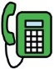
Phone:
Email:
email
phone
address

My special needs are:
Health Passport 3

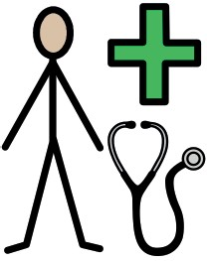
GP Surgery:
doctor
Doctors name:
Phone:

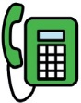
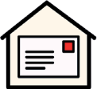
Next of kin contact: Relationship:
Address:
Postcode:
Phone: Email:
email
phone
address

Other services/professionals involved with me:
(Example: Social Services, Health Visitor, Community Nurses)
4 Health Passport

Communication

My preferred language:
Interpreter requirements:

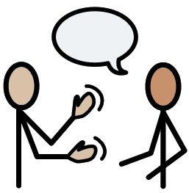
How I would like you to communicate with me:
How I communicate:
communication

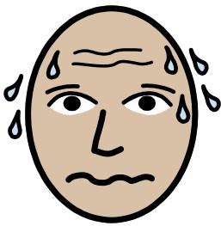
How you can help me if I’m anxious:
anxious

Health Passport 5

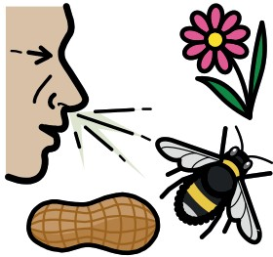
Allergies:
allergy

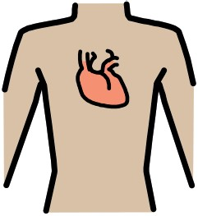
Heart/breathing problems:
heart

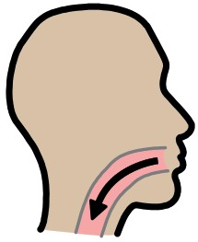
Risk of choking:
swallow
6 Health Passport

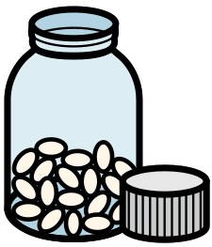
Medication I take:
medication
How I take medication:

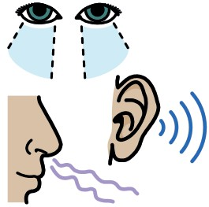
My sensory needs:
sensory
Things to consider in the environment:

Health Passport 7

My medical past

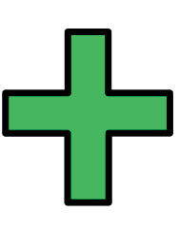
Previous medications, operations, illnesses:
health

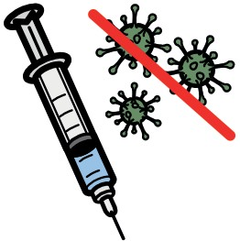
Immunisations I’ve had:
vaccine
8 Health Passport

Things I like:
happy

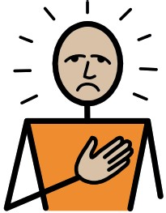
Things I don’t like:
sad

Health Passport 9

My special needs are:

Adjustments that will help me:

My parent/carers name is:
10 Health Passport

Useful links:

https://localofferwirral.org/ https://thepositivitree.com/ https://wired.me.uk/ https://www.mymind.org.uk
https://www.nhs.uk/conditions/learning- disabilities/going-into-hospital/
https://www.mencap.org.uk/

https://www.cwp.nhs.uk/services-and- locations/services/wirral-community-learning- disability-service/
https://www.wuth.nhs.uk/our-departments/ a-z-of-departments/learning-disability-and- autism-team/

Health Passport 11

