- Open AdHoc, select “Patient Care” file and then
“Accessible Information”

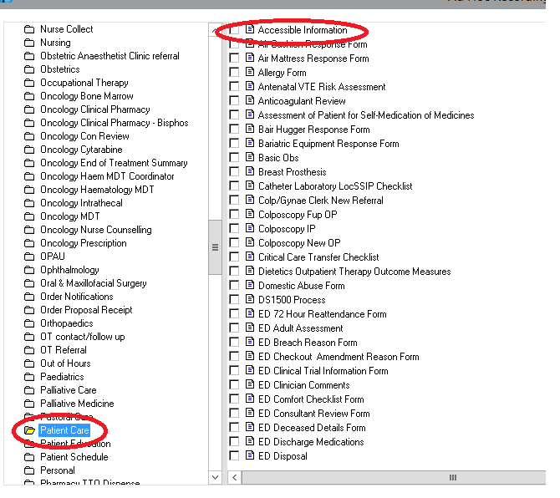

- Select “Yes” if the patient has accessible information needs
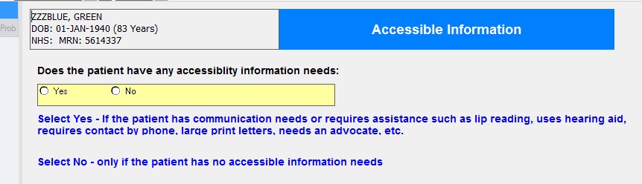

- Follow the steps outlined, starting with opening the “alerts” folder
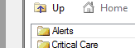

- Then “Accessible Information”
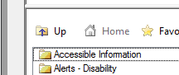

- You can then enter as many details as required. The more details that are entered, the more useful the alert will be.
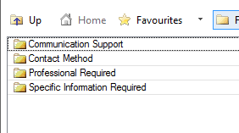
- A flag is then entered onto the banner bar

