Standard Operating Procedure

Record
All Routes lead to the ‘Accessible Information Problems’ PowerForm.
Instructions to complete the form are written in blue on the form (highlighted here by red box)

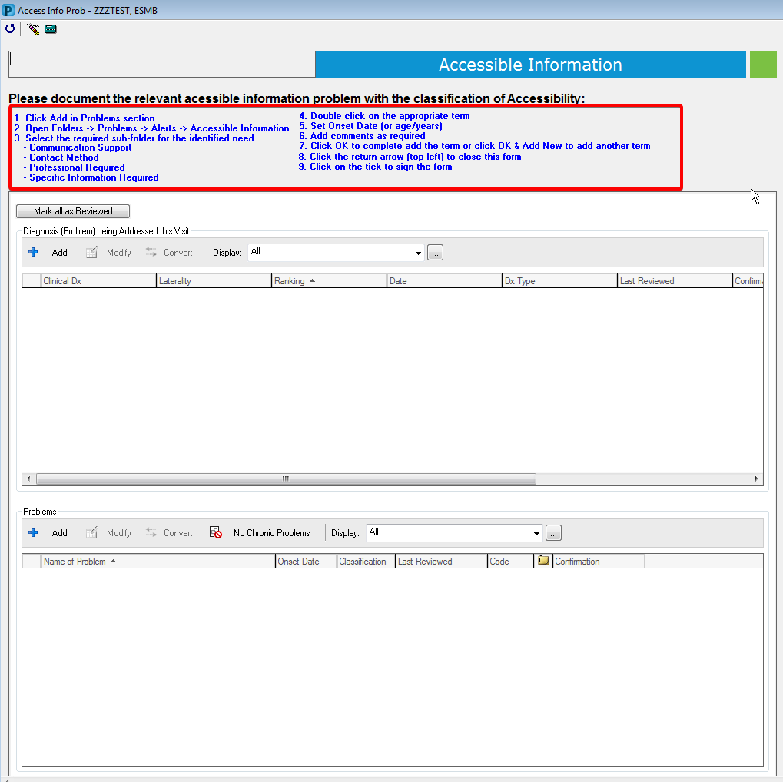

Once completed click on the back arrow to return to the previous form for sign-off, alternatively, click the green tick to sign-off this form depending on the method used in the Ask stage.

Alert / Flag / Highlight
If an Accessible Information need is recorded against a patient then the open patient chart alert should fire to ALL user roles accessing the patient record to inform the member of staff that the patient has communication needs.

