Access to funds via the grants process

The grant application process will run no more than quarterly, and the value of each grant application can be for no more than £2,000. The process is as follows:

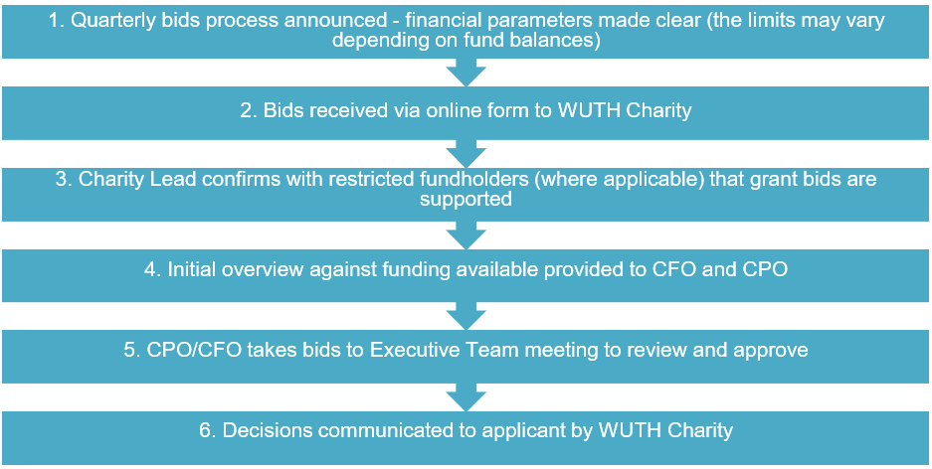

For restricted funds with funding available above the minimum threshold level, up to 50% of the available funds may be committed to the grants process. Should the funds be below the minimum level, a nominal value may be made available via the Patient Wish Fund subject to approval by the Patient Wish Fundholders.

Access to funds outside of grants process

Restricted fundholders can authorise spend from their own funds, should their balance be above the minimum threshold, up to £250 without the requirement of a business case or further scrutiny. The completed fund request form should be submitted to wuth.charity@nhs.net following the guidance set out on the form.

If the request is between £250 and £30,000 (threshold outlined in the SFIs) the fund request form must be completed but approval will follow the same process as the grant applications. It is anticipated that requests will be for much larger projects (exceeding the £2k outlined in the grants process) and these requests can be submitted at any time.

Approval of all spend will be dependent upon the funds being above the minimum threshold required and cannot take the fund into a deficit position.

