Wirral Breast Unit
Student Education Pack



Student Nurse Information for Wirral Breast Unit Clatterbridge

Welcome to the Breast Unit at Clatterbridge Hospital - part of the Women’s and Children’s Division.
The unit offers many learning opportunities for nursing students, and we look forward to sharing our knowledge and skills with you.
You will have the opportunity during your placement to observe and participate in a variety of outpatient services that we provide.
We hope you will enjoy working alongside us as part of our team and that you will find the work here rewarding as well as challenging at times.

The services provided are holistic, incorporating both the physical care and psychological support that people who have a diagnosis of breast cancer or other breast concerns often require.
Nursing staff rotate to cover a variety of clinics including new patients, young persons, fast diagnoses, wound and follow-up clinics. They also support the screening department, attend screening and symptomatic MDTs, carry out consent appointments, HNAs (Holistic Needs Assessments), family history clinics, health promotion and signposting to other services, well-being workshops, and other educational events.
Flexibility and versatility are very much key elements in our department. Times for starting and finishing shifts may vary according to the area that you are working in so please negotiate these with your mentor. We recognise that students will have a range of experience and learning needs and we will endeavour to assist you in fulfilling your personal aims and objectives. How these objectives will be met will be discussed with your mentor.
Staff on the Breast Unit place great value on sharing ideas, knowledge and experience and you will be encouraged to do the same. We believe this is an integral part of professional development in addition to the taught/facilitated formal components you will receive.

The Out- Patient services we provide are as follows:

- Diagnostic Services and Screening Support

- Cancer clinics

- Fast diagnosis clinic

- Young patient Clinics

- Family History Clinic

- Supportive Self-Management and Surveillance

- Health and wellbeing workshops

- Consent / Holistic Needs Assessment

- Prothesis Fitting Service

- Tattooing Service

- Educational Events

- Psychological support
The Wirral Breast Unit Team

We have five Consultants Breast Surgeons based at the Clatterbridge site.
Mr. S. Poonawala Miss. M. Callaghan Mr. J. Lund Mr. R. Vinayagam Mr. R. Burrah
GPSIs (GP with Special Interest) Dr H Bailey, Dr C Hicks and Dr A Meyrick.
In addition, we have Advanced Nurse Practitioner Daphne Taylor and Surgical Care Practitioner Bincy Vinu, plus a registrar and clinical fellow in the unit.
Research Specialist Nurse- Liz Bailey
Macmillan Breast Clinical Nurse Specialists - Katie Firth, Jennie Mealor, Sam Hodkinson, Julia Rimmer, Leanne Murray
Wound Care Nurse/Breast Clinical Nurse Specialist- Karen James
Clinical Support Workers to support medical and nursing staff within clinics

Screening Department

Consultant Radiologists – Dr. A. Talib, Dr. A. Roberts, Dr. J. Findlay, Dr. S. Millington
Radiology Team
Clinical Support Workers

Additional Support Staff

Cancer Care co-ordinator - Leanne Burke
Secretaries – Nikki Griffiths, Wendy Draper and Tracey Clampitt
TCI Clerk Barbara Tyrer Breast Clerk – Emma Dykes
Clerical staff

Learning Resources Available

The biggest resource that we have is the knowledge of the doctors and nursing staff. Please do not hesitate to approach them as they have a wealth of experience for you to draw up on and will be only too happy to share with you.

We have a variety of breast related articles, standards, protocols, procedural information and nursing documentation available. In the clinic we have a vast array of information leaflets on breast conditions and treatments, please feel free to help yourself to these.

As adult learners you are expected to take a pro-active role in the facilitation of education and experiential learning whilst on placement in the Breast Unit, we encourage you to pursue all information available to support your learning experience.

We encourage self-directed study usually between the hours of 4pm and 5pm. During this ‘study hour’ you can focus on completing the workbook or concentrate on an area of interest/learning aspect of your choice. You will be asked to feedback to your shift mentor on your learning achievement and are encouraged to ask any questions.

Triple assessment
This is the gold standard of breast care comprising clinical examination, diagnostic breast imaging and biopsy. Breast imaging forms part of triple assessment, the imaging used is determined by symptoms, clinical findings and the age of the patient.
Results of breast imaging are presented using the BI-RADS (Breast Imaging Reporting and Data System) which was developed by the American College of Radiology (2013). It applies to mammography, ultrasound and MRI.
R1-normal
R2-benign
R3-indeterminate, likely benign
R4-indeterminate, likely cancer
R5- cancer
Sometimes referred to as M1-M5 for mammograms and U1-U5 for ultrasound

Diagnostic tests and associated procedures

Clinical examination/palpation Mammograms

Ultrasound scan Fine needle aspiration –FNS

Core/USS guided biopsy Vacuum assisted biopsy

Stereotactic biopsy Wire guided localisation

USS Magseed Blue dye mapping

Skin marker Radio-isotope injection
Treatment Modalities

Surgical procedures
Mastectomy (including risk reducing mastectomy), Wide Local Excision (WLE/lumpectomy), WLE via therapeutic mammoplasty technique, Axillary node clearance, Sentinel lymph node biopsy, re-excision of margins, symmetrisation surgery, lipo-modelling, reconstructive surgery – implant based (Clatterbridge General Hospital) or autologous (using own tissue - undertaken at Whiston Hospital)

Endocrine therapy and aromatase inhibitors;
Tamoxifen, Letrozole, Examestane, Anastrozole

Chemotherapy
Chemotherapy drugs are given in neo-adjuvant (prior to surgery) and adjuvant settings (post-surgery) as well as for breast cancer that has spread (metastatic or advanced breast cancer). Taxanes, such as paclitaxel (Taxol), docetaxel (Taxotere), and albumin-bound paclitaxel (Abraxane) Anthracyclines (Doxorubicin, pegylated liposomal doxorubicin, and Epirubicin) Platinum agents (cisplatin, carboplatin)

Immunotherapy/Targeted therapies
Trastuzumab (Herceptin), Abemaciclib, Palbociclib

Radiotherapy
Usually given as a daily session over a period of 5 or 15 days (excludes weekends)

Bisphosphonate Therapy
Oral tablets OD or IV given in 6 monthly cycles
Potential side effects of treatments

Post-Surgery
Seroma, infection, lymphedema, shoulder stiffness, axillary web syndrome – cording, altered sensation/numbness/tingling/nerve damage (temporary or permanent), altered cosmesis, altered body image, psychological distress, anxiety, depression

Endocrine Therapy
Fatigue, menopausal symptoms, insomnia, depression, anxiety (can be switched to alternative medication if current one not tolerated)
Dexa Bone scans are undertaken to check on bone health as this oral medication can deplete calcium from the bones leading to osteopenia or osteoporosis.

Radiotherapy
Swelling or shrinking of breast tissue, skin irritation or reactions, fatigue

Chemotherapy
Fatigue, nausea, vomiting, diarrhoea or constipation, hair loss, neutropenia, peripheral neuropathy, infections, anaemia, bruising, bleeding, anorexia, sore mouth, skin and nail changes, sex and fertility issues, memory and concentration issues, insomnia
Echocardiograms are commonly undertaken to check on cardiac function prior to patients starting chemotherapy.

Psychological disorders
Anxiety, depression, body dysmorphia, Post Traumatic Stress Disorder, sexual dysfunction
Common Breast Disorders and Diseases

Benign Disorder Malignant Disorder

Breast Cyst DCIS (Ductal carcinoma in situ)

Mastitis IDC (Invasive ductal carcinoma)

Breast pain Invasive Lobular Carcinoma

Breast Abscess Paget’s disease of the nipple

Fibroadenoma Mucinous Carcinoma

Gynaecomastia

Galactorrhea

Fibrocystic breast disease

Other Disorders

LCIS (Lobular carcinoma in situ)

Anatomy of the breast

AIM:
To gain knowledge and understanding of the structure and function of healthy breasts.
To introduce the student to a variety of breast conditions.
OBJECTIVES:
The learner will be able to:
- List the structures found in the breast
- Understand the function of healthy breasts
- Describe the cause and effect of common breast disorders

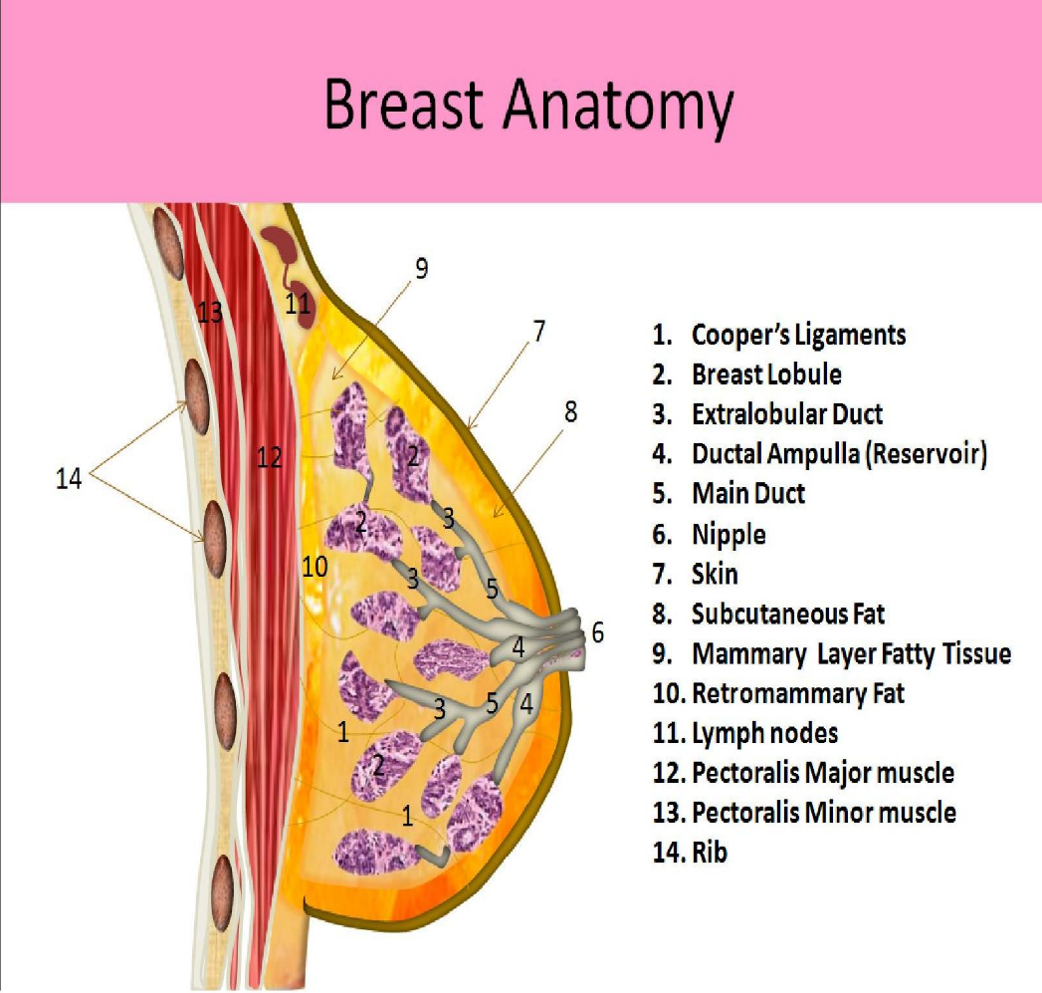

Lobules and ducts
Each breast has a number of sections (lobules) that branch out from the nipple. Each lobule holds tiny, hollow sacs (alveoli). The lobules are linked by a network of thin tubes (ducts). If you're breast-feeding, ducts carry milk from the alveoli toward the dark area of skin in the center of the breast (areola). From the areola, the ducts join together into larger ducts ending at the nipple.

Lymphatic System

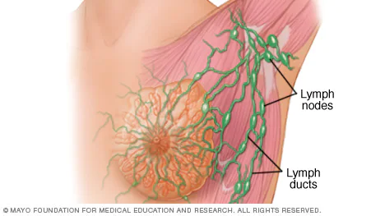
Lymph nodes and lymph ducts
The lymphatic system is a system of thin tubes called lymph vessels and lymph nodes or glands that help our bodies get rid of toxins, waste and other unwanted materials including infections and cancer cells. Lymph nodes — found under the armpit, above the collarbone, behind the breastbone and in other parts of the body trap harmful substances that might be in the lymphatic system and safely drain them from the body. The spleen, thymus, tonsils and adenoids are also part of the lymphatic system.
Lymphoedema

If the lymph vessels or nodes are blocked, removed or damaged, it can cause a build-up of lymphatic fluid which can cause swelling to areas of the body, primarily the limbs, this is known as lymphoedema.
Cancer or cancer treatments such as surgery involving removal of lymph nodes or radiotherapy can affect the fluid drainage channels of the lymphatic system, this results in fluid that doesn't drain in the normal way, so the area then swells and can feel heavy.
The incidence of patients who will have lymphoedema of the arm at some point after being treated for breast cancer varies from between 5% following sentinel lymph node biopsy (SLNB) to 20% following axillary node clearance (ANC).

If lymphoedema is not treated, it may get worse, become painful and make it difficult for the patient to move their arm. Patients who undergo any axillary surgery should be advised not to have injections, bloods or blood pressure readings taken on the affected arm. Prompt onward referral to the lymphoedema service should be made for assessment and symptom management.

For more information about lymph0edema and cancers of the lymphatic system go to Cancer Research UK.org slash lymphoedema.

Psychological aspects of breast disease

AIM:
To raise awareness of psychological and sociological aspects of breast disease.
OBJECTIVES:
The learner will
⦁ Describe the psychological impact of breast disease
⦁ Identify the sociological impact of breast disease
⦁ Demonstrate appropriate interpersonal interaction with patients.
⦁ Discuss the rationale for an HNA and care planning
Spend time observing nursing and medical interactions with patients (where appropriate) to understand the effect their cancer diagnosis has for them and their family.
Using the worksheet as a guide make comments and reflect on your findings.
How do you think/how did the patient feel at suspicion, diagnosis, pre-surgery and post-surgery? How has treatment affected them? How has this diagnosis and subsequent treatments affected their self- image, relationships, social life, work, etc?
Reflective area:
………………………………………………………………………………………………………………………………………………………………………………………………………………………………………………………………………………………………………………………………………………………………………………………………………………………………………………………………………………………………………………………………………………………………………………………………………………................................................................................................................................................................................................................................................................................................................................................................................................................................................................................................................................................................................................................................................................................................................................................................................................................................................................................................................................................
…………………………………………………………………………………………………………………………………………………………………………………………………………………………………………………………………………………………………………………………………………………………………………………………………………………………………………………………………………………………………………………………………………………………………………………………………………………………………………………………………………………………………………………………................................................................................................................................................................................................................................................................................................................................................................................................................................................................................................................................................................................................................................................................................................................................................................................................................................................................................................................................................................................................................................................................................................................................................................................................................................................................................................................................................................................................................................................................................................................................................................................................................................................................................................................................................................................................................................................................................................................................................................................................................................................................................................................................................................................................................................................................................................................................................................................................................................................................................................................................................................................................................................................................................................................................................................................................................................................................................................................................................................................................................................................................................................................................................................................................................................................................................................................................................................................................................................................................................................................................................................................................................................................................................................................................................................................................................................................................................................................................................................................................................................................................................................................................................................................................................................................................................................................................................................................................................................................................................................................................................................................................................................................................................................................................................................................................................................................................................................................................................................................................................................................................................................................................................................................................................................................................................................................................................................................................................................................................................................................................................................................................................................................................................................................................................................................................................................................................................................................................................................................................................................................................................................................................................................... ……………………………………………………………………………………………………………………………………………………………………………………………………………………………………………………………………………………………………………………………………………………………………………………………………………………………………………………………………………………………………………………………………………………………………………………………………………………………………………………………………………………………………………………………………………………………………………………………………………………………………………………………………………………………………………………………………………………………………………………………………………………………………………………………………………………………………………………………………………
Breast Quiz

- What % of women will be diagnosed with breast cancer in their lifetime?

- Name two types of breast cancer

- How many ductal systems does a breast commonly have?

- What is the tissue extending into the axilla called?

- Where does the main lymphatic drainage of the breast take place?

- In the UK, approximately how many women are diagnosed with breast cancer each year?

- List 3 risk factors for breast cancer

- What percentage of breast cancers are caused by a faulty gene?

- What changes should women look for during breast self-examination?

- What % of women will commonly experience breast Pain?

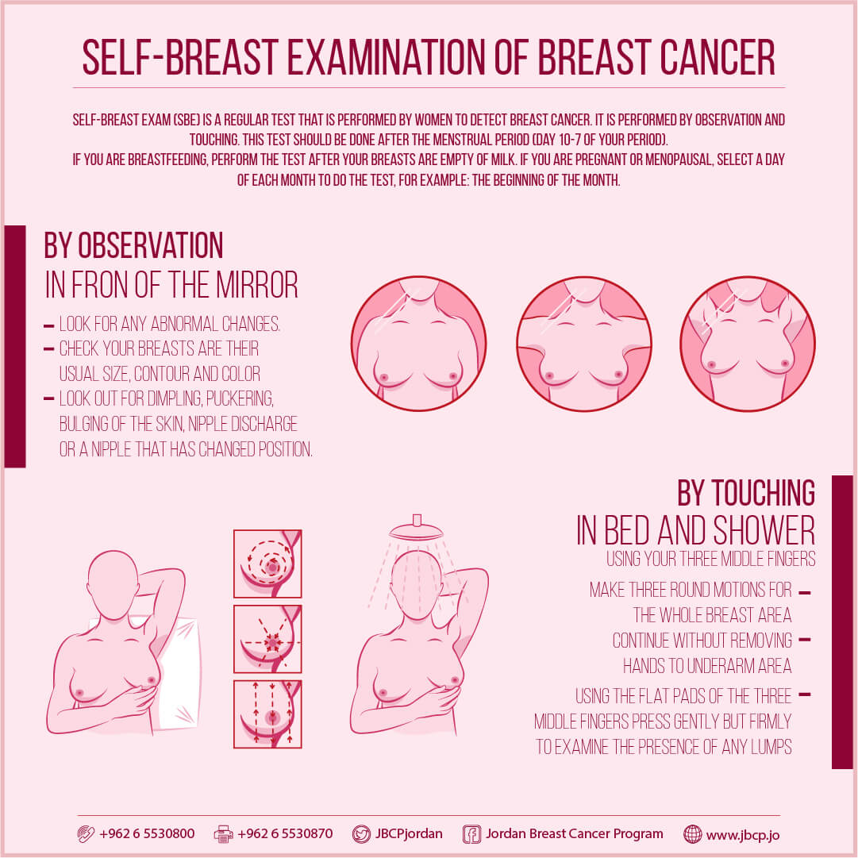

ADDITIONAL REASOURCES

https://www.macmillan.org.uk/

https://breastcancernow.org/

https://www.cancerresearchuk.org/

https://coppafeel.org/

https://www.nhs.uk/conditions/breast-cancer/

https://bnf.nice.org.uk › treatment-summaries › breast-cancer

https://www.royalmarsden.nhs.uk › information-gps › gp-resources › breast-cancer

https://associationofbreastsurgery.org.uk › patients

https://www.nationalbreastcancer.org › educational-guides

