Colorectal Macmillan Team.

The Colorectal team consists of the following staff;
- 7 consultants
- 3 CNS’s including lead CNS
- 2 Cancer support workers

Our role, as the Macmillan cancer team, is to support any patient with a suspected or confirmed bowel cancer. We support patients from referral through to their diagnosis, ensuring that all investigations in the interim are done in a timely manner to meet the 28 day target that the patient is usually referred to us on.

Referrals.
Most patients are referred on a 2WW (2 week rule) but we do receive referrals in alternative ways such as CT alerts – unexpected findings, emergency presentations – admitted to hospital due to obstruction, etc.

Patient journey/pathway.
Most patients follow the same route of investigations but there are often patients that need to have alternative and/or further investigations depending on their age, the type of tumour and if it is structuring, spread of disease, etc.
- Colonoscopy tends to be a patients first investigation if they are referred in via GP on a 2WW pathway.
- CTVC – CT virtual colonoscopy – this is done as an alternative for patients who may have had a colonoscopy but was unsuccessful as the camera scope was unable to pass the suspected tumour aka stricture, which limits the endoscopist to visualise what is inside of the bowel. A CT virtual colonoscopy is performed, and this looks at the bowel from a different angle and in a different way but to the same effect of a colonoscopy.
- CT TAP – CT thorax, abdomen and pelvis is also an investigation that is performed for patients on our pathway, this image covers the lower chest area, to check for any disease in the lungs, abdomen to assess the bowel and the pelvis to look at the surrounding organs i.e the liver to see if any disease is present there also. This investigation allows the radiologist to stage the tumour and to also inform the team of any metastatic disease that may be present in other organs.
- MRI pelvis/rectum – this scan is only performed on patients that have suspected rectal cancer as the MRI imaging gives us better results and staging.
Once all or most of the above investigations are performed, we will have the patients case discussed at our local multi-disciplinary team meeting (MDT). The reason for this meeting is that it allows specialists from different areas to provide the consultants and our team of a diagnosis for patients that have been referred to us. We have the following members of staff present at this meeting for different reasons.
- Histopathologist present at this meeting, who gives us the results of the biopsies that the patient has had taken during the colonoscopy. This specimen is sent to the labs following the colonoscopy and it is looked at under a microscope.
- Radiologist present at the meeting to discuss the results of the CT, CTVC & MRI scans that the patients have had done to also provide us with a staging.
- Oncologist is also present to determine whether a patient should have neoadjuvant treatment prior to surgery, or if a patient that has had surgery should have adjuvant treatment. As well as patients that are not a surgical candidate and are palliative.
- Colorectal surgeons/consultants are also present as the patients are under their care and will be reviewed in clinic post MDT meeting to be given the MDT outcome and treatment plan.
- CNS is present to provide information on the patient, this is often personal information such as smoking status, alcohol intake, performance status, this often helps determine if a patient is an ideal candidate for surgery or treatment etc.
- Colorectal support worker is also present to capture the patients that need to be seen in clinic post MDT meeting and to arrange appointments with the appropriate specialists.
Each patient’s case is discussed amongst the specialists and a treatment plan is decided and agreed upon by the team. Depending on the outcome, the patient will either be seen in clinic by a consultant with a CNS present, to be given their diagnosis and treatment plan or a patient is sometimes contacted by a CNS to be informed that they require a further investigation such as a PET scan or MRI scan to complete staging. These scans are done to determine if there is any disease in other areas of the body which will also determine the treatment plan for the individual. Once these further investigations are performed the patient’s case will be rediscussed at MDT, a plan will be made and then they will be seen in clinic by the consultant with a CNS present.

- HNA – Holistic Needs Assessment will be offered to the patient after clinic when they receive their diagnosis and treatment plan. Some patients are happy for the HNA to be completed at the time whilst others prefer it to be done later, which would be followed up by a telephone call to complete this.
- GP Gatekeeper – the patients GP surgery will be informed of their diagnosis and treatment plan via email by our admin assistant.
Treatment Plan
Depending on the outcome for the patient and the treatment plan determines what referrals and pathway that they will go on.

Straight To Surgery
SERC MDT
Remove polyps endoscopically in Liverpool
Christies MDT
Complex cases
NET MDT
Neuroendocrine tumour
Anal MDT
Treatment for anal cancer is performed in Liverpool
ACMDT
Advanced cancers MDT -to assess liver/lung disease management
Rectum –
Chemoradiotherapy
Colon/mets –
Chemotherapy
Neo-Adjuvant treatment – refer to oncologist
Pre-Hab – to optimise fitness pre-surgery
Stoma Team referral
(if required)
Anaesthetic review
(if required)
Pre-Op Assessment &
ERP nurse review

Referral to another MDT meeting
Best Supportive Care/
Palliative Care
Adjuvant Chemo
Refer to oncologist
Appropriate for patients who have positive lymph nodes post surgery in the specimen biopsy
Arrange colonic stent
Defunctioning stoma

Liver biopsies

Interventions for symptoms

Refer to hospice for OPA
Refer to community Macmillan nurse if clinically indicated
Refer to District Nurse if appropriate
Follow up care/
Remote Surveillance
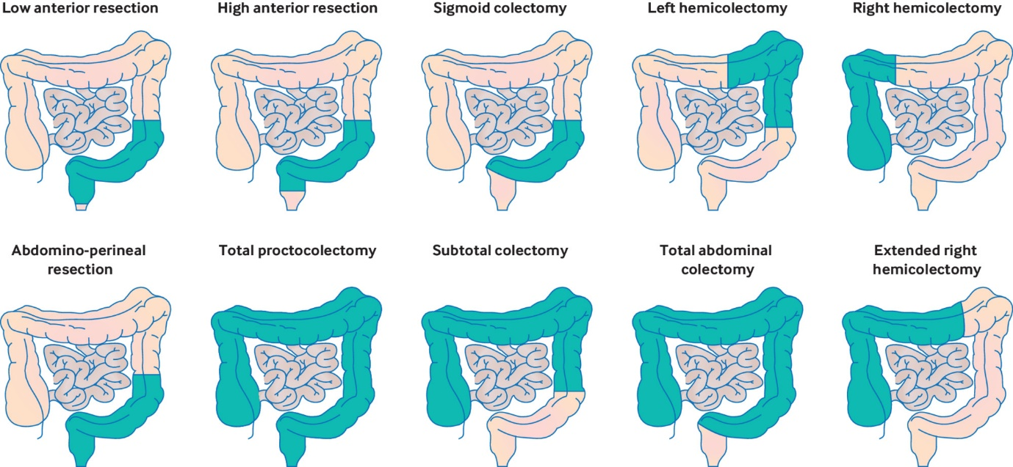
The diagram below shows the different types of bowel surgery that is performed on our patients.
Patients sometimes have recurrence and will be discussed at MDT meeting and plan will be made from there.
Patients are notified of results of investigations by patient poral or via letter
Patients who have had ‘curative treatment’
Five year follow up programme
Workshop to show patients what remote surveillance is
Colonoscopy – one year post op and four years post op
Blood tests every 6 months for five years
Sign posts to
Support services e.g. Maggies, Pre/Rehab
Promotes patients to be independent with their care with living with and beyond cancer
Patient will still be under the care of consultant but CSW will be first point of contact
Aim for this is to avoid patients having to come to clinic for results
CT TAP – once a year for five years

