Lung Cancer Welcome pack

Welcome to the Lung Cancer team. We are based in an office outside of Ward 33 on the 3rd floor. Our contact number is 0151 604 7482.

We hope you enjoy your placement with us. Please feel free to ask any questions to enhance your learning.

Who is in the team?
Dr Andrew Wight - lead consultant
Support workers - Lynne Bevan and Polly Dunning
Clinical Nurse specialists Paula Deus and kay Hughes
We have wider members who form our MDT (Multidisciplinary meeting) including radiologists, pathologists, oncologists and surgeons.

What do we do?
We are involved when patients are suspected of having primary lung cancer. We telephone patients initially to assess patients so that investigations are commenced without delay. We help in arranging the tests and support patients throughout their diagnostic tests. We liaise closely with the Lead Consultant to ensure results are acted on in a timely manner. We see patients in clinic and once results are available, often it is the CNS who informs the patients of their cancer diagnosis.

Referrals
We follow the national lung cancer optimum pathway. This means that patients all patients suspected of having cancer have a CT scan before being seen. A CT is automatically performed when a chest x-ray is suspicious of cancer and is reported within 72 hours. A suspected lung cancer CT can be requested if there is clinical suspicion of cancer even if the x-ray is normal.
Sometimes lung cancer is found incidentally when the patient does not have symptoms for example a trauma CT after an accident or when admitted with a chest infection. Our patients therefore can come into the service by differing routes.
Often we see patients on the ward when there CT scan shows a lung cancer, we organise investigations although generally these are performed as an outpatient.
Not every abnormal CT turns out to be cancer but we support all patients when suspected as we recognise the anxiety this causes. We inform patients on the day the CT is reported if cancer is ruled out.

Anatomy of the lung

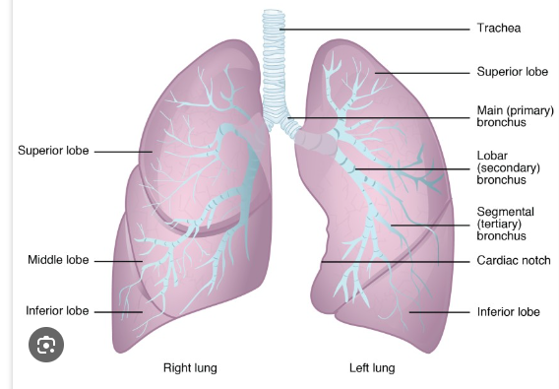

Investigations
Tests are needed to establish a lung cancer diagnosis (We only look after primary lung cancer so if the tests show it’s a metastatic cancer from another primary for example a colorectal metastases we refer to the correct team).
We use the TNM to stage . This is important as it guides which treatment is best for each patient
T - Tumour N - lymph nodes M - metastases

Making a diagnosis can be complex and often the patient has multiple investigations. The patient may need the following investigations
Imaging
CT scan - a staging Ct thorax with contrast in all patients. Some patients have a CT head to check there is no cancer spread
PET scan - depends on the stage but if staging means can be offered more radical treatment a PET is performed (we will give you a leaflet which explains about this scan)
MRI - may be needed of organs such as the liver or adrenal glands if concern of cancer spread. May be done of the head to check there is no spread of cancer to the brain.

Sampling cell type
Bronchoscopy - a camera test to sample tumours in the airway
EBUS - Sampling lymph nodes in the chest
Ct guided biopsy - to sample the cancer directly, patients need satisfactory lung function as a complication can be a pneumothorax.
Neck node biopsy - sampling lymph nodes in the neck
Liver biopsy - sampling liver metastases
Mediastinoscopy - Sampling lymph nodes in the chest that an EBUS can’t reach. This is done under a GA at Liverpool

Cell type
Non small cell
- About 80% of patients have this type. This type includes Adeno, squamous and large cell
Small Cell
- An aggressive form of cancer
There are other less common types of tumour for example carcinoid and thymoma

MDT
All patients are discussed in the Lung MDT to have a management plan of treatment. The MDT is weekly on a Tuesday lunch time.

Lifestyle
Treatment depends on how well a person is to receive treatment. We assess this using a performance status scale. To increase performance status patients are referred to prehabilitation services. If a patient is a smoker it is beneficial to stop, we refer to the stop smoking team for their support.

Treatment
Once all investigations are complete and discussion has taken place in the Lung MDT patients are referred for
Surgery - For earlier stage cancer when there is no spread. All surgery is performed at Liverpool Heart and Chest Hospital. There are different types of surgery. The most common is a lobectomy.
Oncology - treatments include chemotherapy, radiotherapy, immunotherapy or targeted treatment. The treatments are given at CCC Wirral or Liverpool.
Surveillance - if a patient has a small tumour that can’t be sampled it may be monitored by CT scans to look for growth
Best Supportive care- for patients who can’t be offered treatment or decline treatment. We would ask the GP to monitor and refer to palliative care if develop symptoms.
Palliative care - When there are symptoms to manage.

Holistic needs assessment (HNA)
Patients are offered a HNA to elicit their concerns which we work with the patient top resolve. This may be by referring to other forms of support.

Learning Resources available
We can help in arranging for you to observe procedures such as bronchoscopy and EBUS
You will attend the weekly MDT
You can attend a cancer clinic and shadow the CNS in their role

Websites
Roy castle - https://roycastle.org
Macmillan - Macmillan.org.uk

Different types of surgery

