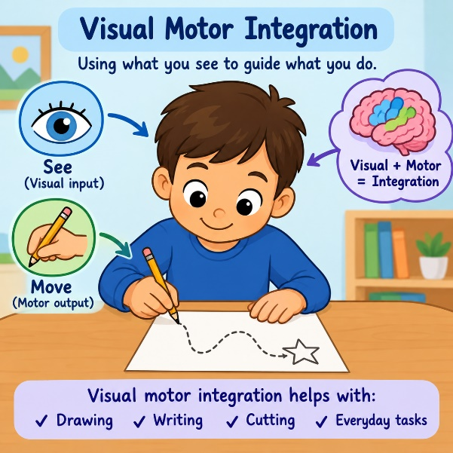

What is visual motor integration (VMI)?
Visual motor integration (VMI) is the ability to coordinate visual information with physical movements, allowing the eyes and hands to work together efficiently. This coordination is essential for everyday tasks like writing, drawing, and playing sports

What are the implications?
Children with VMI problems may have difficulties with:
- Construction tasks, e.g. jigsaws, threading, Lego®, building models
- Self-care, e.g. dressing, using cutlery
- Holding and manipulating tools, e.g. underlining with ruler, cutting along a line with scissors.
- Pencil and paper tasks, e.g. tracing, colouring within lines, drawing, learning letter formation, designs needing directional changes
- Presentation – spacing, staying within lines, consistent sizing of writing
- Copying from book to paper, or board to paper
- Performing practical tasks
- Copying and reproducing shapes/designs especially when orientation, spatial placement and direction are involved
- PE, e.g. ball skills, team games, apparatus work.
General strategy ideas to develop VMI skills
Activities to develop and strengthen VMI skills can be categorised by the type of motor skill and engagement required:

✍️ Fine Motor & Paper Tasks
- Get child to practice paint with paintbrush and use a glue pen to stick items.
- Practice using small ruler with dot-to-dot activities. Stickers can be placed on ruler to give guideline of where to put fingers.
- To develop writing/ drawing skills: imitating and copying lines, shapes, letters and numbers using different materials, e.g. play dough, Plasticene®, lolly sticks, pipe cleaners.
- Maze activities: start with media such as shaving foam or sand before drawing on paper. Progress to pencil mazes, grading width of maze, difficulty and distance between objects.
- Tracing activities: trace lines (straight, curved, zig-zag) and shapes before advancing to tracing numbers or letters.
- Colouring activities.
- Use stencils and get your child to draw around objects.
- Do word searches and dot-to-dot activities.
- Peg patterns, copying patterns drawn on square or circle grids, completing symmetry patterns and tessellations.
- Copying drawings and locating grid positions
- Find the shortest route on maps/ mazes
- Directional drawings with eyes closed, e.g. follow verbal directions; ‘up stop’, ‘to the right stop’. Draws: shapes, letters, words with eyes closed, from verbal instructions
- Picture/ word matching card games.
- Origami/ paper folding activities.
- Threading activities: Thread colourful beads, pasta, or cereal onto a string. Try copying specific colour sequences. Initially start with large equipment and progressing to smaller.
- Tearing activities.
- Scissor Practice: Cut out shapes and pictures. Start with wide, straight lines and graduate to complex, curved ones.

🧱 Building & Manipulation
- Block Copying: Build a design or pattern with blocks first, then have the child copy your model. For older kids, use pattern cards to teach step-by-step assembly.
- Puzzles & Lacing: Interlocking jigsaw puzzles or lacing cards to encourage spatial planning.

🎈 Gross Motor & Coordination
- Throw and Catch: play catch with various sizes, shapes, and weights of balls (e.g., beach balls, bouncy balls) to improve hand-eye coordination.
- Target games: throwing beanbags or balls to a target.

Classroom strategies to support VMI
- Simplify motor activities, so less accuracy is needed.
- Allow more time to complete task.
- Provide tactile, visual or auditory cues to help guide movements e.g. increase width of line to be cut or size of space to be coloured.
- Allow the child to focus on content of creative writing tasks rather than presentation.
- Consider alternative methods of recording work, while handwriting skills continue to develop.
- For older children, introduce laptop in conjunction with touch typing software to improve typing skills for recording work.

